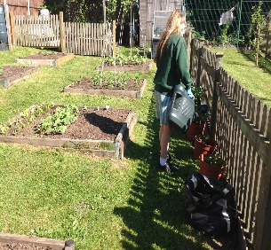
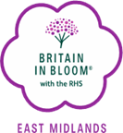
EMIB Schools Competition 2026
Do you have young ‘Green Fingered’ gardeners in your school?
This could be just what you are looking for to celebrate their
hard work this school year!!
We recognise the Overall Best School Junior and Senior Garden in the East Midlands

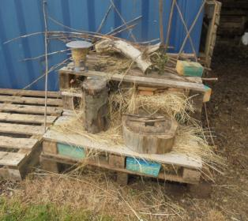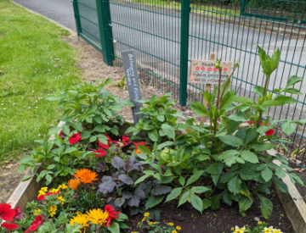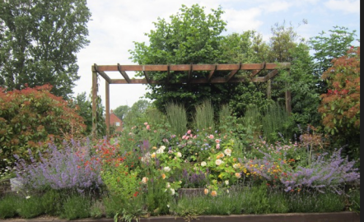

The overall winning school and any winners of the judges discretionary awards, will be invited to send representatives to the Awards Presentation in September.
All participating schools will subsequently receive a certificate and written report in recognition of their endeavours.
If you would like to enter please contact your local “In Bloom” group, if you don’t know who your group is, or you know there isn’t one in your area please
Contact our secretary at East Midlands in Bloom on 07925 565346 or secretary@emib.org.uk
We have handy School Garden Award guidelines and requirements for entry available on our website www.emib.org.uk click the EMIB Competition tab
Good luck and we look forward to hearing from you!
If you feel you would like to participate this year and be part of the competition in 2026, please complete the entry form and return to
schools@emib.org.uk by Thursday April 30th 2026

